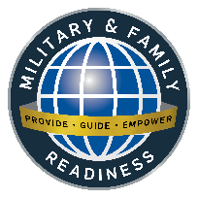
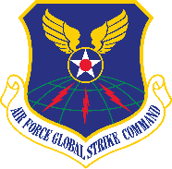
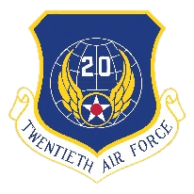
Military & Family Readiness Center (M&FRC)
Consolidated Support Facility - Building 20245, Suite 126
To register for classes or make an appointment. please call (505) 846-0741/0751
or send email to 377FSS.FSH.MFRF@us.af.mil
2025
July
SUNDAY | MONDAY | TUESDAY | WEDNESDAY | THURSDAY | FRIDAY | SATURDAY
 | 30  TAP Workshop 0800-1600 Room 120 | 1 | 2 | 3 | 4  Independence Day  M&FRC Closed | 5
6 | 7 | 8 | 9 | 10 | 11 | 12
 | AFGSC Family Day  M&FRC Closed | Car Buying 101  1330-1500 M&FRC Training Rm |  | DOL Employment Track 0800-1600 Room 120  Ditching the Dorms  1330-1500 M&FRC Training Room | Bundles for Babies  0900-1130 M&FRC Training Room
13 | 14 | 15 | 16 | 17 | 18  Demystifying Real Estate  0900-1200 M&FRC Training Room | 19
 | Separatee Group Briefing  0800-1200 Room 120  -------------------------------------------------------------------------------------------------------------------------  Saving, Investing, and TSP  1330-1500 M&FRC Training Room | Retiree Group Briefing  0800-1200 Room 120  -------------------------------------------------------------------------------------------------------------------------  First Duty Station - Officer  1300-1500 M&FRC Training Room | Newcomers’ Welcome Orientation, Info Fair &  Bus Tour  0730-1400 Room 120 | 377 ABW Training Day  M&FRC Closed | -------------------------------------------------------------------------------------------------------------------------  Hiring Event  0900-1200 Room 120
20 | 21 | 22 | 23 | 24 | 25 | 26
 | Financial Planning for the Holidays  1330-1500 M&FRC Training Rm | Career and Credential Exploration 0800-1600 Room 120  Financial Planning for Divorce  1330-1500 M&FRC Training Rm | Federal Resume  0800-1130 M&FRC Training Rm  -------------------------------------------------------------------------------------------------------------------------  Financial Planning for Marriage  1330-1500 M&FRC Training Rm | Ditching the Dorms  1330-1500 M&FRC Training Room
27 | 28 | 29 | 30 | 31
 | Military Spouse 101  1000-1400 M&FRC Training Rm  -------------------------------------------------------------------------------------------------------------------------  PCS Financial Training  1330-1500 M&FRC Training Rm | Retiree Group Briefing  0800-1200 Room 120 | Newcomers’ Welcome Orientation, Info Fair &  Bus Tour  0730-1400 Room 120 | Separatee Group Briefing  0800-1200 Room 120 | M&FRC events in the Kirtland app  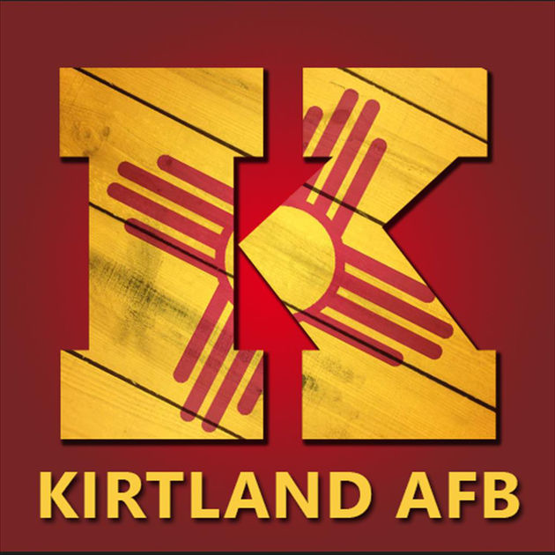
377 ABW Retiree Activities Office
(505) 846-1536
377ABW.CVR.RetireeActivities@us.af.mil
 | Casualty Assistance Representative and Survivor Benefits Plan (SBP)  Jesus Palomino-Alcantar 505-846-5508 jesus.palomino_alcantar@us.af.mil  Lacie Peregrine-Bennett 505-853-1717 lacie.peregrine-bennett@us.af.mil | Personal Financial Readiness  Kathy Hobbs 505-853-1718 kathleen.hobbs.1@us.af.mil  Aaron Arner 505-853-1713 505-220-8732 (cell) pfc.kirtland@MagellanFederal.com |  | Military & Family Life Counselors are here to listen. MFLCs are available to help Service Members, Spouses, Family Members, and children. NO RECORDS ARE KEPT  (505) 415-4027 * (505) 440-2481 * (505) 730-0080 |   Tabitha Bush  505-853-1707 tabitha.bush.2@us.af.mil    Kirtland AFB Military & Family Readiness Center | Earn Leadership Pathways Points. Attend M&FRC events.  


Military & Family Readiness Center (M&FRC)
Consolidated Support Facility, Building 20245, Suite 126
To register for classes or schedule an appointment, call (505) 846-0741/0751 or
send an email to 377FSS.FSH.MFRF@us.af.mil
TAP Workshop  30 June-2 July 2025, 0800-1600 Room 120 | Step 3 of the Transition Assistance Program (TAP) is the 3-day TAP Workshop and one or more of the 2-day Transition Tracks. The TAP Workshop helps transitioning Service members prepare for civilian life and meet the mandatory Career Readiness Standards. Initial Counseling and Preseparation Counseling must be completed before attending the TAP Workshop. Dress code is casual civilian business attire. No uniforms. Participants should bring their personal laptop to use for workshop activities. Spouses are welcome and encouraged to attend.
Car Buying 101  8 July 2025, 1330-1500 M&FRC Training Room | Members will receive information and resources in reference to making educated car purchases.
DOL Employment Workshop  10-11 July 2025, 0800-1600 Room 120 | The 2-day DOL Employment Workshop covers emerging best practices in career employment, including in-depth training to learn interview skills and build effective resumes. Initial Counseling, Pre-separation Counseling and the 3-day TAP Workshop must be completed before attending this workshop. Dress code is casual civilian business attire. No uniforms. Participants should bring their personal laptop to use for workshop activities. Spouses are welcome and encouraged to attend.
Ditching the Dorms  10 & 24 July 2025, 1330-1500 M&FRC Training Room | Offered in conjunction with Military Housing Office, the purpose of this class is to educate members of the process and help financially prepare for the cost of moving into their own place. Discussion will include financial readiness, initial costs, renter’s insurance, the importance of emergency savings for unexpected costs.
Bundles for Babies  11 July 2025, 0900-1130 M&FRC Training Room | Bundles for Babies provides valuable information to help parents prepare and adjust to a new baby. Local experts will share knowledge and answer questions. Air Force, Space Force, Navy, Marine and Coast Guard families will receive a $150 deposit from AFAS. 25 Leadership Pathways Points
Separate Group Pre-Separation Counseling  14 & 31 July 2025, 0800-1200 Room 120  Retiree Group Briefing (SBP Mass Briefing & Pre-Separation Counseling)  15 & 29 July 2025, 0800-1200 Room 120 | Step 2 of TAP is Pre-Separation Counseling which must be accomplished at least 365 days before separation or retirement. Pre-Separation Counseling ensures Service members are informed of the services and benefits available to assist them and their families with the transition to civilian life. Spouses are welcome and encouraged to attend.  The SBP Mass Briefing is mandatory all retiring Service members.
Saving, Investing, and TSP  14 July 2025, 1330-1500 M&FRC Training Room | Financial Touchpoint Training for members hitting their 2nd year of service and being vested in the TSP. Covers various saving, investing and TSP options giving more information about Blended Retirement System and TSP matching.
First Duty Station - Officer  15 July 2025, 1300-1500 M&FRC Training Room | Financial Touchpoint Training required of all new officers reporting to their first duty location. Purpose to understand military money, Blended Retirement System, Federal and state taxes, vesting allowances, manage your money, mortgage or rent, Thrift savings plan, developing a spending plan and net worth, impact of credit, debt management.
Newcomers’ Welcome Orientation, Info Fair & Bus Tour  16 & 30 July 2025, 0730-1400 Room 120 | This mandatory event is for personnel new to Kirtland AFB to accomplish required briefings and provide information from key agencies. The Info Fair and Bus Tour of Kirtland AFB follows the briefings. Continental breakfast and Lunch provided. Spouses are welcome and encouraged to attend.  30 Leadership Pathways Points (Awarded for family members Only)
Demystifying Real Estate  18 July 2025, 0900-1200 M&FRC Training Room | Engaging discussion to learn the ins and outs of the Real Estate process as well as current trends and changes in the industry. Covering all the steps of the home buying or selling process to include mortgage lending and working with a Realtor.
Hiring Event  18 July 2025, 0900-1200 Room 120 | Your new career awaits! Job seekers are encouraged to dress professionally and bring multiple copies of their updated résumés. Numerous employers will be present. Active Duty, Guard, Reserve, Retirees, DoD Civilians, and Eligible Family Members are encouraged to attend this FREE event.
Career and Credential Exploration  21-22 July 2025, 0800-1600 Room 120 | The 2-day Department of Labor (DOL) Career and Credential Exploration (C2E) offers a unique opportunity for participants to complete a personalized career development assessment of occupational interest and ability. Participants are also guided through a variety of career considerations, including labor market projections, education, apprenticeships, certifications, and licensure requirements.
Financial Planning for the Holidays  21 July 2025, 1330-1500 M&FRC Training Room | Course highlighting the various holiday related expenses and how to better financially prepare for them over the coming months.
Financial Planning for Divorce  22 July 2025, 1330-1500 M&FRC Training Room | Touchpoint financial information for personnel recently or soon-to-be divorced.
Federal Resume  23 July 2025, 0800-1130 M&FRC Training Room | Learn how to format a federal resume, tailor a resume, and apply on USA jobs.
Financial Planning for Marriage  23 July 2025, 1330-1500 M&FRC Training Room | Touchpoint financial information for personnel recently or soon-to-be married.
Military Spouse 101  28 July 2024, 1000-1400 M&FRC Training Room | Formerly known as Heart Link, Military Spouse 101 is a fun way for spouses new to military life to learn about Air Force customs/traditions, benefits, entitlements, support agencies and services on base. Designed for spouses with 5 years or less in the Air Force, however all spouses are welcome. 40 Leadership Pathways Points
PCS Financial Training  28 July 2025, 1330-1500 M&FRC Training Room | Financial Touchpoint for service members E-6/O-3 and below and their spouses who are relocating due to reassignment and provides information that will help them make and execute sound financial plans.

