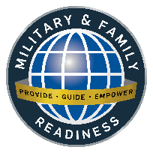
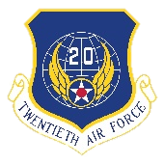
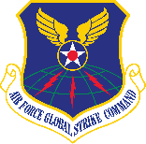
Military & Family Readiness Center
Consolidated Support Facility, Building 20245, Suite 126
To register for class or make an appointment, please call (505) 846-0741/0751
or send email to 377FSS.FSH.MFRF@us.af.mil
August 2025
Sunday | Monday | Tuesday | Wednesday | Thursday | Friday | Saturday
 | Casualty Assistance Representative and Survivor Benefits Plan (SBP)  Jesus Palomino-Alcantar 505-846-5508 jesus.palomino_alcantar@us.af.mil  Lacie Peregrine-Bennett 505-853-1717  lacie.peregrine-bennett@us.af.mil |  |  |  | 1 | 2
Military & Family Life Counselors (MFLC)
(505) 415-4027 (505) 440-2481 (505) 730-0080
The Resource Center has 9 computers with commercial Internet & CAC reader, printer, scanner, phone, fax, job announcements & handouts
3 | 4 | 5 | 6 | 7 | 8 | 9
 | TAP Workshop 0800-1600 Room 120 | Car Buying 101  1330-1500  M&FRC Training Room | Linkedin or Left Out  1330-1430  M&FRC Training Room | DOL Employment Workshop 0800-1600 Room 120  Ditching the Dorms  1330-1500  M&FRC Training Room
10 | 11  Entrepreneurship Track 0800-1600 Room 120 | 12 | 13 | 14 | 15 | 16
 | Saving, Investing and TSP  1330-1500  M&FRC Training Room | New Mexico At Its Best  0900-1100  M&FRC Training Room  ____________________________________________________________________  First Duty Station - Officer  1300-1500  M&FRC Training Room | Newcomers’ Welcome Orientation, Info Fair &  Bus Tour  0730-1400 Room 120  ____________________________________________________________________  VA Benefits 101  1300-1400  M&FRC Training Room | Separatee Group  Pre-Separation Counseling  0800-1200 Room 120 | Hiring Event  0900-1200 Room 120
17 | 18 | 19 | 20 | 21 | 22 | 23
 |  | Retiree Group Briefing  0800-1230 Room 120  ____________________________________________________________________  Financial Planning for Divorce  1330-1500  M&FRC Training Room | Plan My Move  0800-1100 Room 120  ____________________________________________________________________  Resume Workshop  0900-1100  M&FRC Training Room ____________________________________________________________________  Financial Planning for Marriage  1330-1500  M&FRC Training Room | 377 ABW Training Day  M&FRC Closed | _  Demystifying Real Estate  0900-1200  M&FRC Training Room
24 | 25 | 26 | 27 | 28 | 29 | 30
 | PCS Financial Readiness Training  1330-1500  M&FRC Training Room  Earn Leadership Pathways Points by attending M&FRC events.   | M&FRC events in the Kirtland app  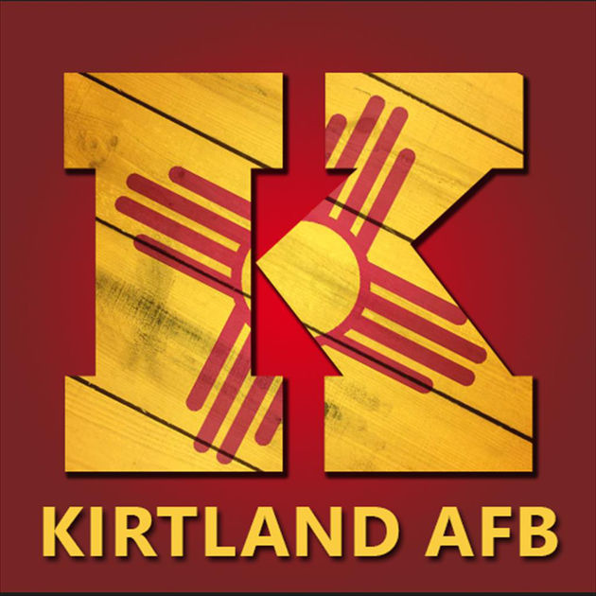 | Newcomers’ Welcome Orientation, Info Fair &  Bus Tour  0730-1400 Room 120 | Ditching the Dorms  1330-1500  M&FRC Training Room | Family Day  M&FRC Closed
31 |  |  |   Tabitha Bush  505-853-1707  tabitha.bush.2@us.af.mil    Kirtland AFB Military & Family Readiness Center |  |  | Kathy Hobbs, Personal Financial Readiness  505-853-1718 kathleen.hobbs.1@us.af.mil  Aaron Arner, Personal Financial Counselor  Office 505-853-1713 Mobile 505-220-8732  pfc.kirtland@magellanfederal.com

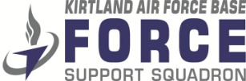
Military & Family Readiness Center (M&FRC)
Consolidated Support Facility, Building 20245, Suite 126
To register for classes or schedule an appointment please call (505) 846-0741/0751
or send email to 377FSS.FSH.MFRF@us.af.mil
TAP Workshop  4-6 August 2025, 0800-1600 Room 120 | Step 3 of the Transition Assistance Program (TAP) is the 3-day TAP Workshop and one or more of the 2-day Transition Tracks. The TAP Workshop helps transitioning Service members prepare for civilian life and meet the mandatory Career Readiness Standards. Initial Counseling and Pre-Separation Counseling must be completed before attending. Casual civilian business attire. No uniforms. Participants should bring their personal laptop to use for workshop activities. Spouses are welcome and encouraged to attend.
Car Buying 101  5 August 2025, 1330-1500 M&FRC Training Room | In partnership with Sandia Area Credit Union, attendees will learn tools to become an empowered buyer and avoid some of the common pitfalls in the car purchase experience.  15 Leadership Pathways Points
Linkedin or Left Out  6 August 2025, 1330-1430 M&FRC Training Room | Participants learn how to create and optimize their LinkedIn profile, as well as strategies to create content that will attract attention of employers.  15 Leadership Pathways Points
DOL Employment Workshop  7-8 August 2025, 0800-1600 Room 120 | The Department of Labor (DOL) Employment Track is a comprehensive 2-day workshop that covers emerging best practices in career employment, including in-depth training to learn interview skills, build effective resumes, and use emerging technology to network and search for employment. Dress code is casual civilian business attire. Participants should bring their personal laptop to use for workshop activities. Wi-Fi is available in the classroom. Spouses are welcome and encouraged to attend.
Ditching the Dorms  7 & 28 August 2025, 1330-1500 M&FRC Training Room | This class helps Airmen financially prepare for the cost of moving into their own place. Discussion includes financial readiness, initial costs, renter’s insurance, and the importance of emergency savings for unexpected costs
Entrepreneurship Track  11-12 August 2025, 0800-1600 Room 120 | SBA Entrepreneurship provides participants with an introductory understanding of business ownership, an overview of entrepreneurship and applicable business ownership fundamentals. Participants are introduced to the skills, knowledge, and resources they need to launch a business. Spouses are welcome and encouraged to attend.
Saving, Investing and TSP  11 August 2025, 1330-1500 M&FRC Training Room | Financial Touchpoint Training for members hitting their 2nd year of service and being vested in the TSP. Covers various saving, investing and TSP options giving more information about Blended Retirement System and TSP matching.
New Mexico At Its Best  12 August 2025, 0900-1100 M&FRC Training Room | An introduction to New Mexico including food sampling, travel & leisure tips, as well as cultural diversity.
First Duty Station - Officer  7 August 2025, 1300-1500 M&FRC Training Room | Participants will learn about personal financial budgets, debt reduction, Thrift Savings Plan, the Air Force Aid Society, and other financial topics to assist themselves and those they supervise. All first duty station officers are required to attend this brief within 90 days of being arriving at KAFB.
Newcomers’ Welcome Orientation & Info Fair  13 & 27 August 2025, 0730-1400 Room 120 | This event is for personnel new to Kirtland AFB to accomplish essential briefings. Sign-in and breakfast is 0730-0800. Briefings include Base Leadership, SARC, Safety Office, Base Emergency Preparedness Office, IG Office, OSI, 377 SFS, Environmental Office, Public Affairs, Chaplain Corps, Casualty Assistance, Voting Assistance, M&FRC and Family Advocacy. Info Fair and Bus Tour is after the briefings. Continental breakfast and lunch provided. 30 Leadership Pathways Points (Family Members Only)
VA Benefits 101  13 August 2025, 1300-1400 M&FRC Training Room | Introduction to VA and its variety of benefits, services and resources that may support you and your family throughout your military life cycle—some you may use now while you’re on active duty and some you may be able to use later after you separate or retire.
Separatee Group Pre-Separation Counseling  14 August 2025, 0800-1200 Room 120  Retiree Group Briefing  (SBP Mass Briefing & Pre-Separation Counseling)  19 August 2025, 0800-1200 Room 120 | Step 2 of TAP is Pre-Separation Counseling which must be accomplished at least 365 days before separation or retirement. Service members should start TAP 24-14 months before separation or retirement. Pre-Separation Counseling ensures Service members are informed of the services and benefits available to assist them and their families with the transition to civilian life. Spouses are welcome and encouraged to attend.  The Survivor Benefit Plan (SBP) Mass Briefing is mandatory for all retiring Service members. SBP provides the survivors of participating retirees a monthly income that starts when the member dies and retired pay stops. Spouses are welcome and strongly encouraged to attend.
Hiring Event  15 August 2025, 0900-1200 Room 120 | Your new career awaits! Job seekers are encouraged to dress professionally and bring multiple copies of their updated résumés. Numerous employers will be present. Active Duty, Guard, Reserve, Retirees, DoD Civilians, and Eligible Family Members are encouraged to attend this FREE event.
Financial Planning for Divorce  19 August 2025, 1330-1500 M&FRC Training Room | Touchpoint financial information for personnel recently or soon-to-be divorced.
Plan My Move  20 August 2025, 0800-1100 Room 120 | PCS information from the experts. Representatives from TMO, Finance, Claims Office, Military & Family Life Counselors, Kirtland AFB Housing Management Office, Kirtland Family Housing, School Liaison Officer, Exceptional Family Member Program and M&FRC will present information and answer questions.
Resume Workshop  20 August 2025, 0900-1100 M&FRC Training Room | Learn how an effective resume will open the door to your next career opportunity.
Financial Planning for Marriage  20 August 2025, 1330-1500 M&FRC Training Room | Touchpoint financial information for personnel recently or soon-to-be married.
Demystifying Real Estate  22 August 2025, 0900-1100 M&FRC Training Room | Engaging discussion to learn the ins and outs of the Real Estate process as well as current trends and changes in the industry. Covering all the steps of the home buying or selling process to include mortgage lending and working with a Realtor.
PCS Financial Readiness Training  25 August 2025, 1330-1500 M&FRC Training Room | Financial Touchpoint for service members E-6/O-3 and below and their spouses who are relocating due to reassignment and provides information that will help them make and execute sound financial plans.

